Simple Animation Steps Journal
Image | Description
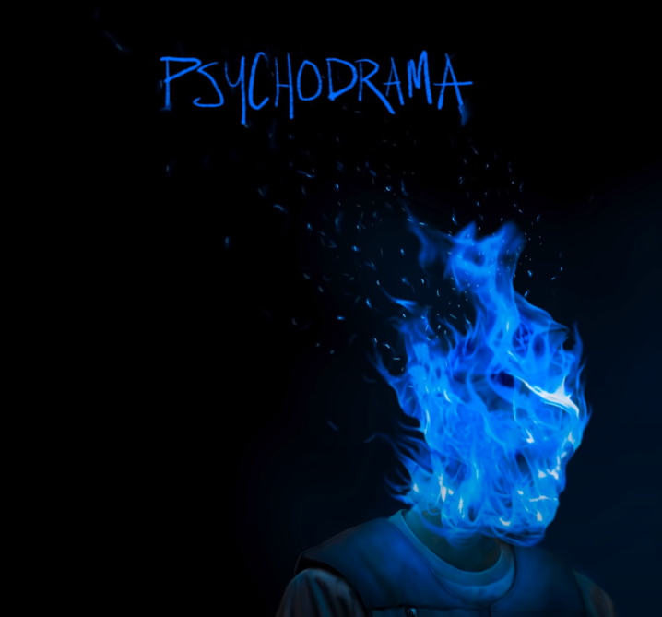 | I used a YouTube video downloader website to get the audio of the song Voices -Dave as that will be our background audio
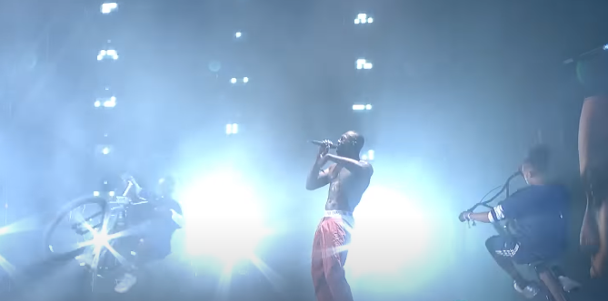 | I used a YouTube video downloader website to get a video of Stormzy Performing being one of our artists
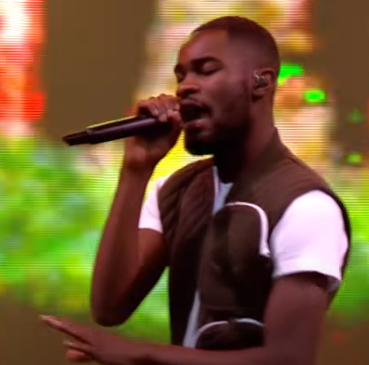 | I used a YouTube video downloader website to get a video of Dave performing being one of our artists
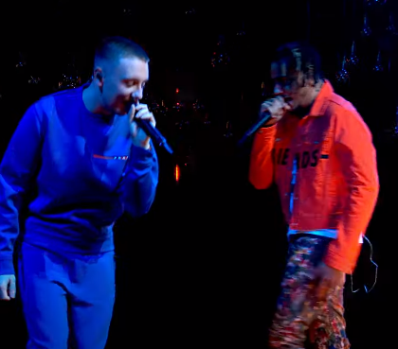 | I used a YouTube video downloader website to get a video of Aitch and AJ Tracey performing being two of our artists
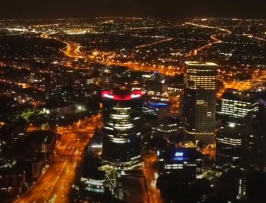 | I used a YouTube video downloader website to get a video of drone footage of Perth
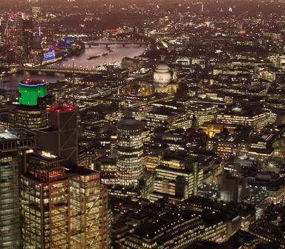 | I used a YouTube video downloader website to get a video of drone footage of London
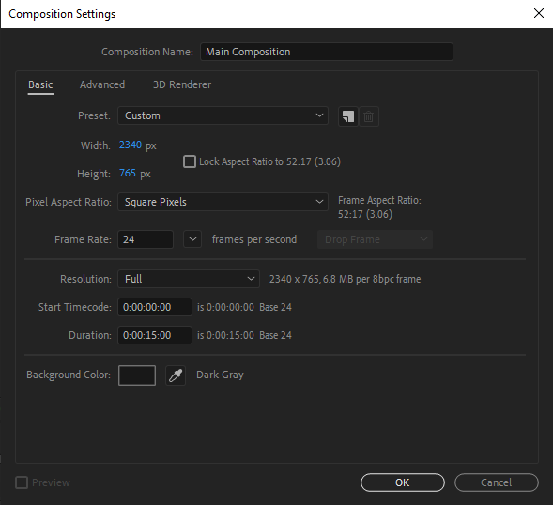 | I created a After Effects Project and composition with the resolution 2340x765, a fps of 24 being the standard and 15 seconds long
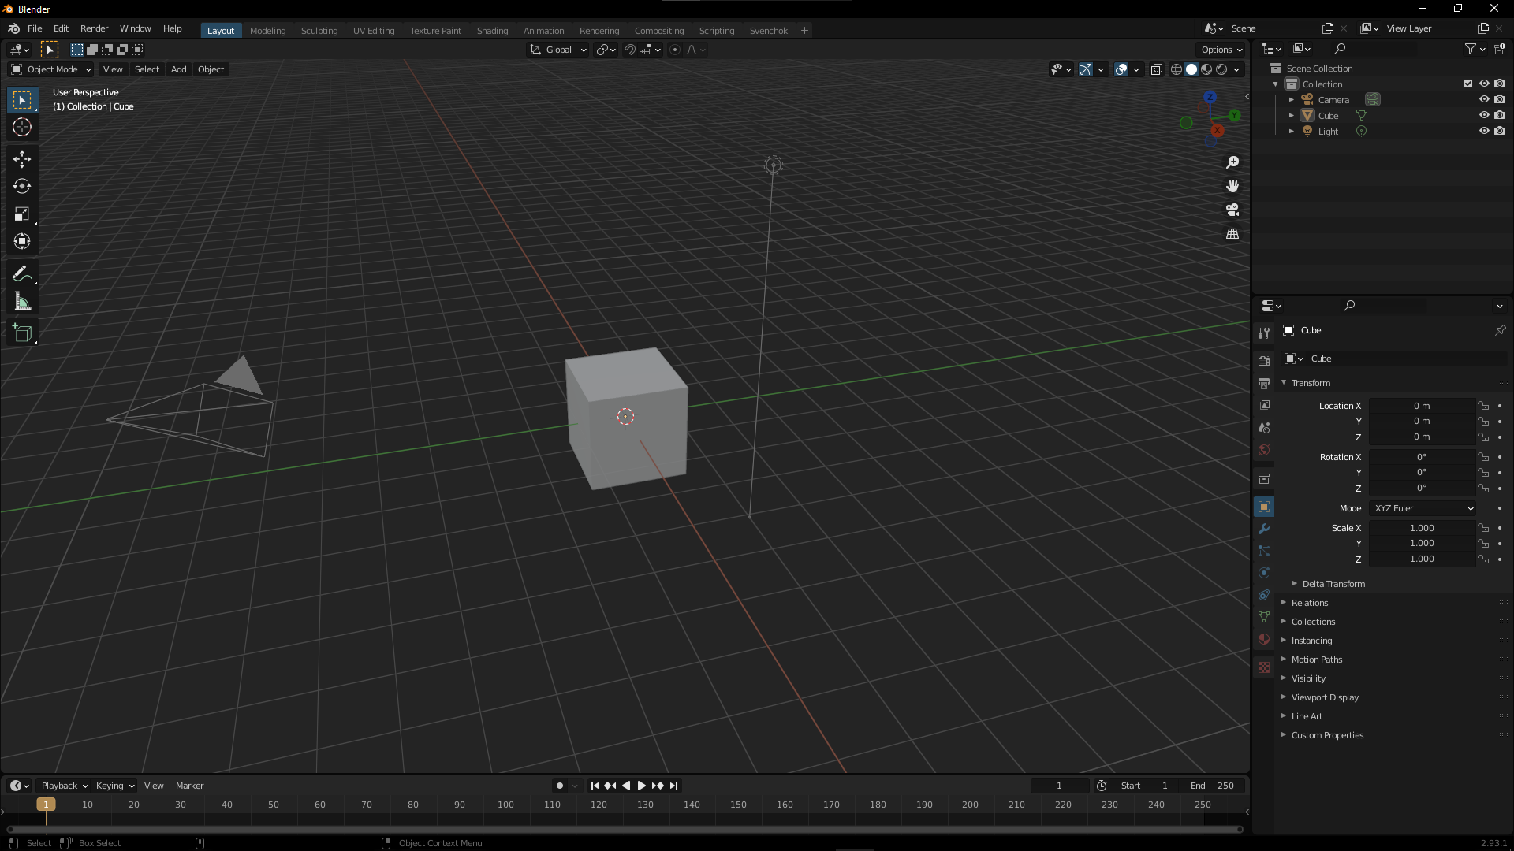 | Create the Blender File
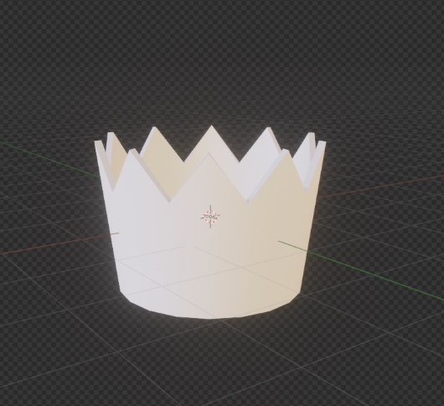 | Delete all objects in the scene and replace it with a crown 3D model
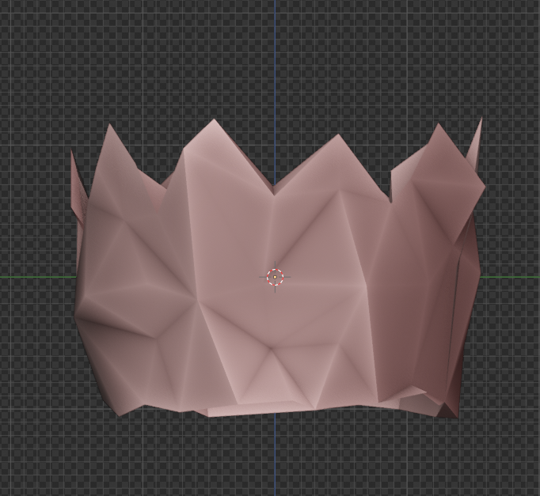 | Then you want to subdivide it, displace it then decimate it
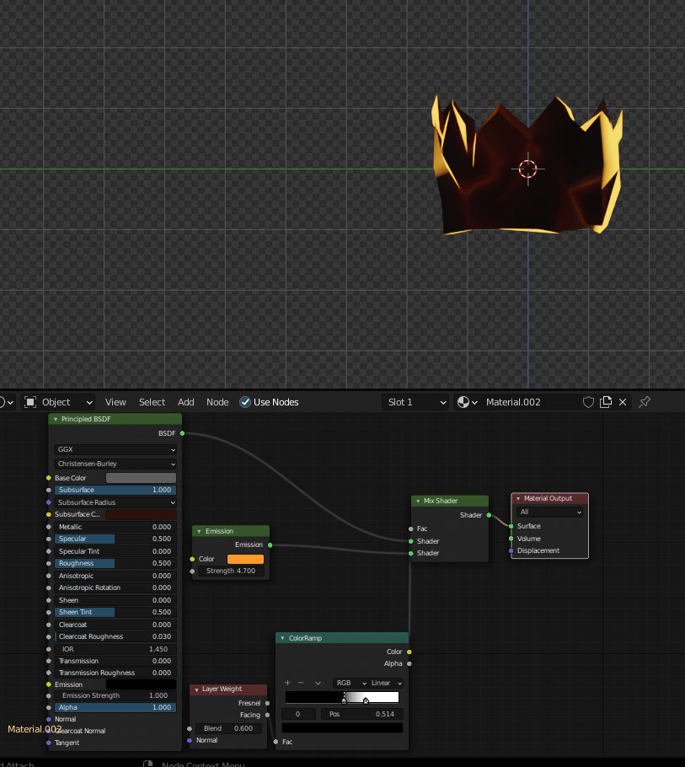 | Then set up a custom shader with nodes
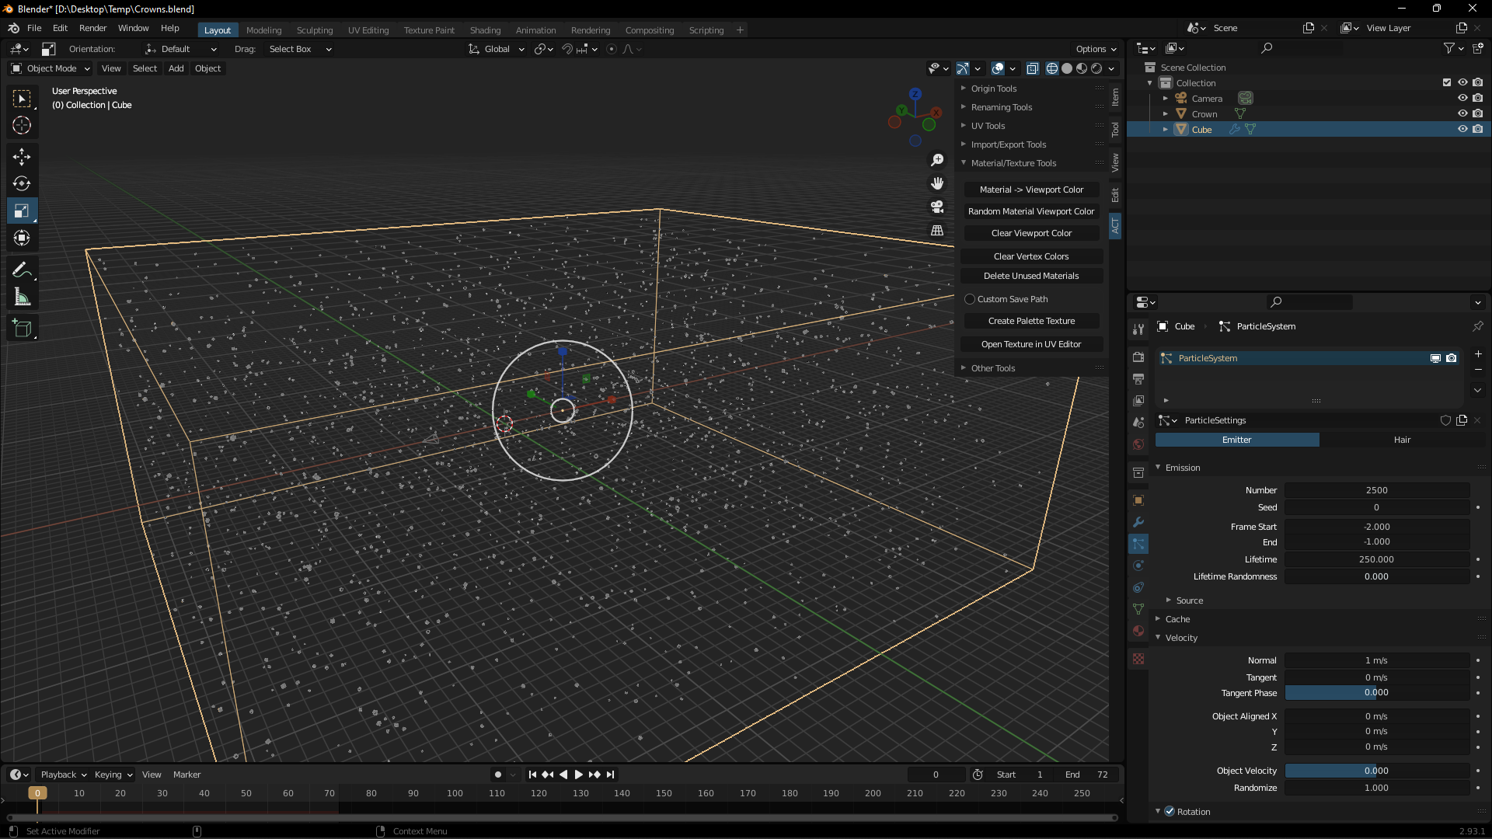 | Then set up a particle system in a box for the crowns
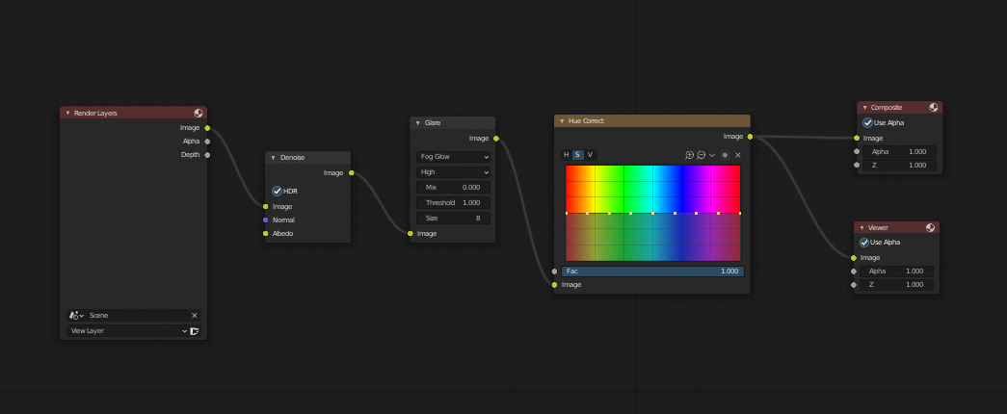 | Then render the video with the following compositing settings
 | Then we’ll get a PNG Hale logo and convert it into a SVG using ink scapes.
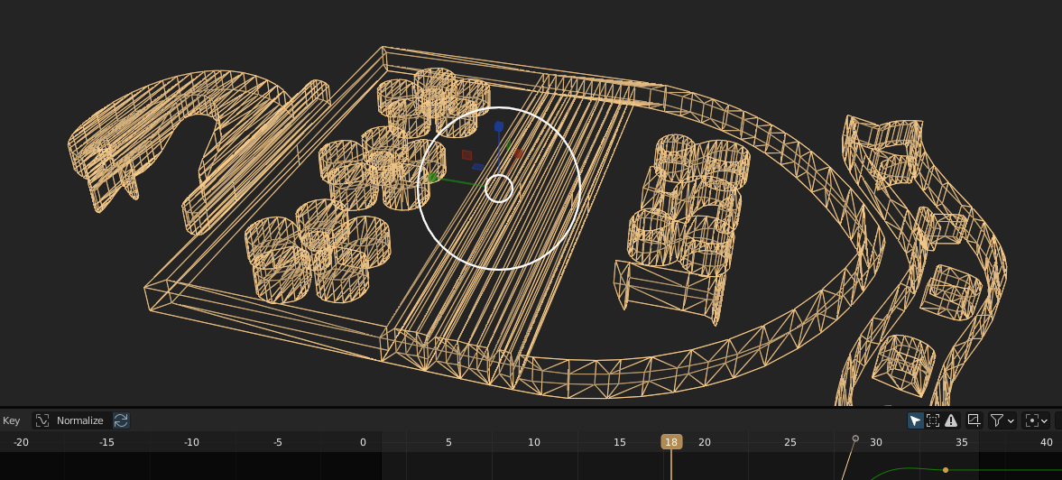 | At this point we’ll decimate any unneeded geometry and solidify it.
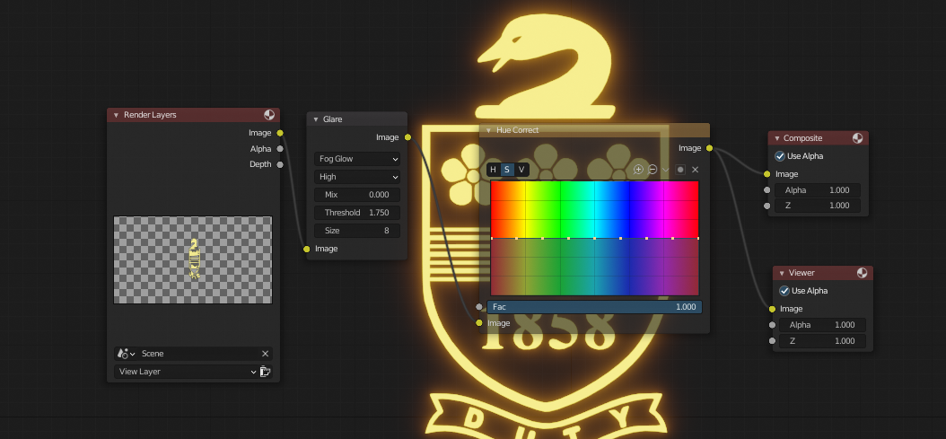 | Following this we’ll give it the following composition nodes.
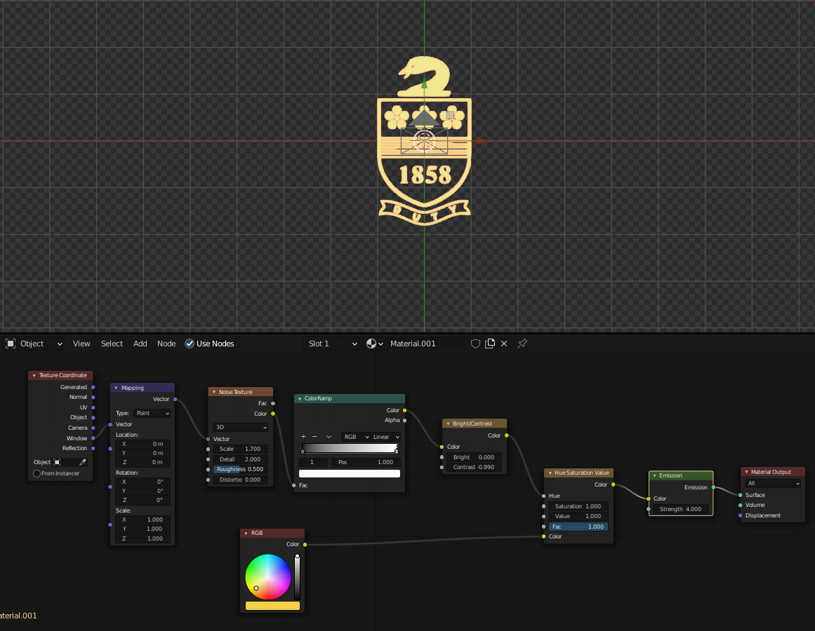 | Then we will add this material shader to it.
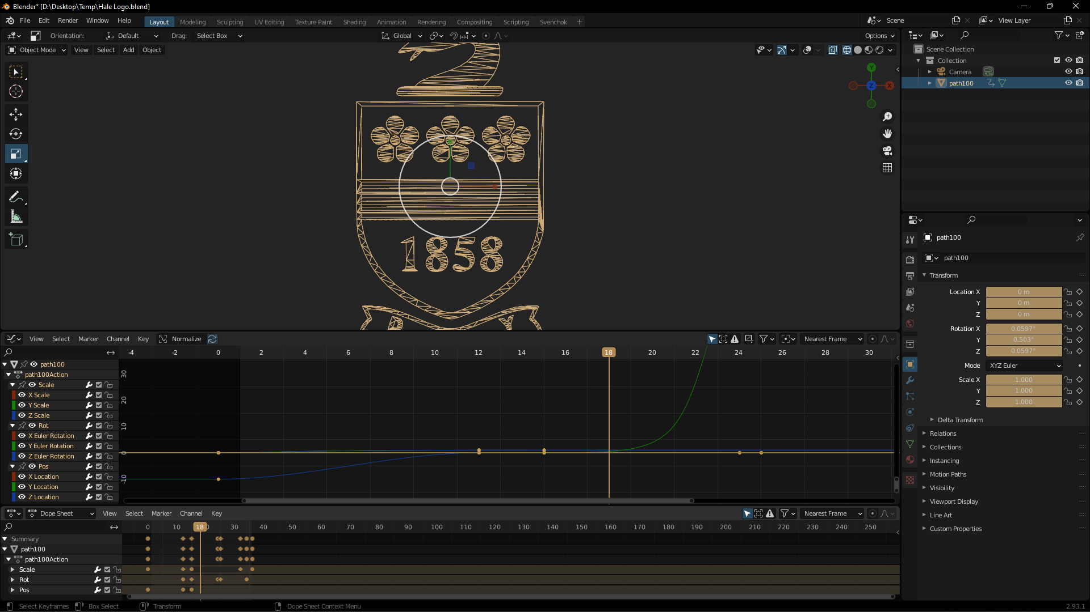 | We will finally animate the position, rotation, and scale of it to make it pop in spin and pop out (further adjustments can be made to the animation tweening with curves)
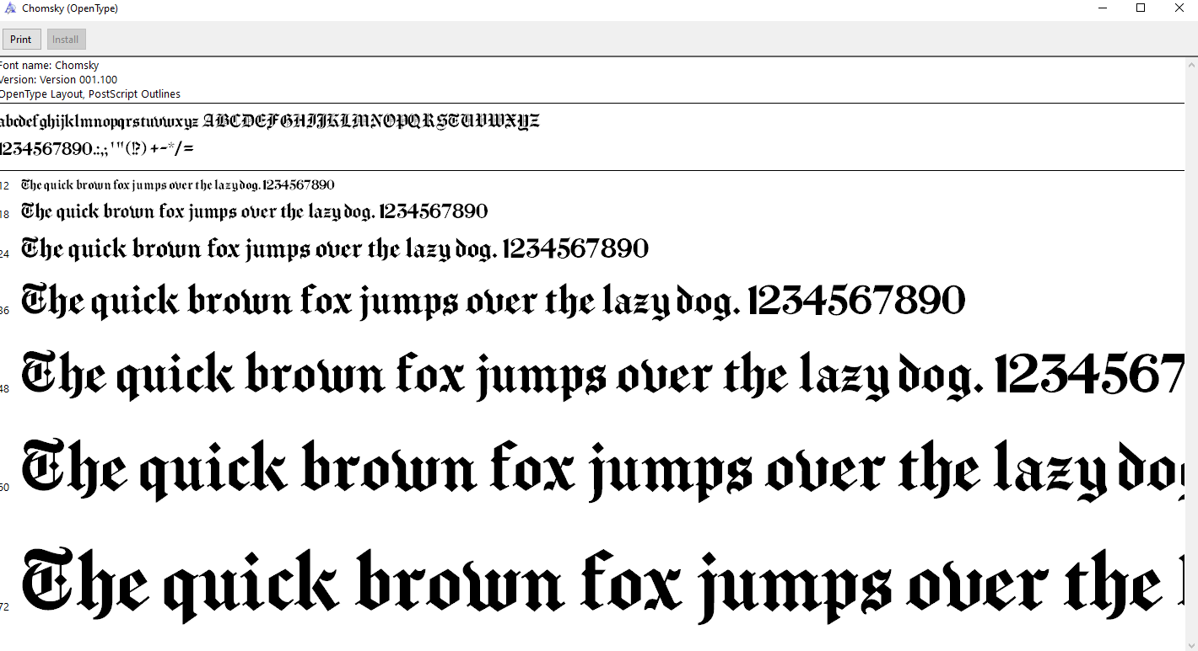 | I found a font I wanted to use, downloaded it and installed it; it’s called ‘Chomsky’
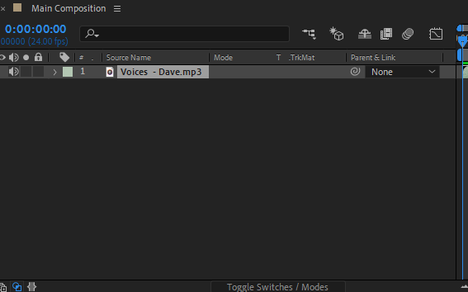 | Drag the music into After Effects and find the point at which we want to start and stop it
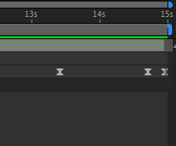 | Add sone key frames to the audio volume so it doesn’t just cut in and out
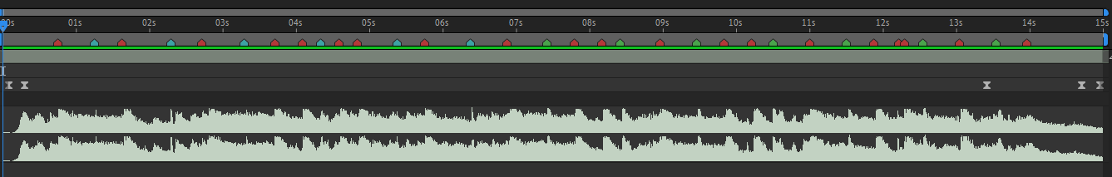 | Now mark all the drops, snares and clicks. Then decide which ones you want to use for transitions.
 | Add in the text and sync them up with the beat.
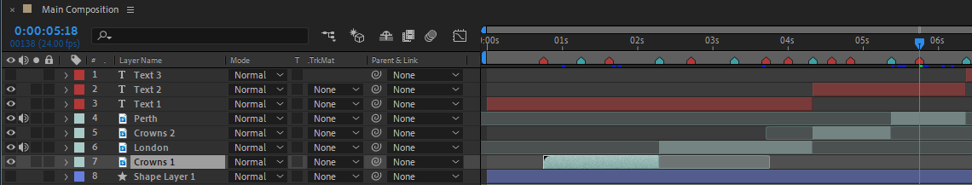 | Sync up the background clips with the audio
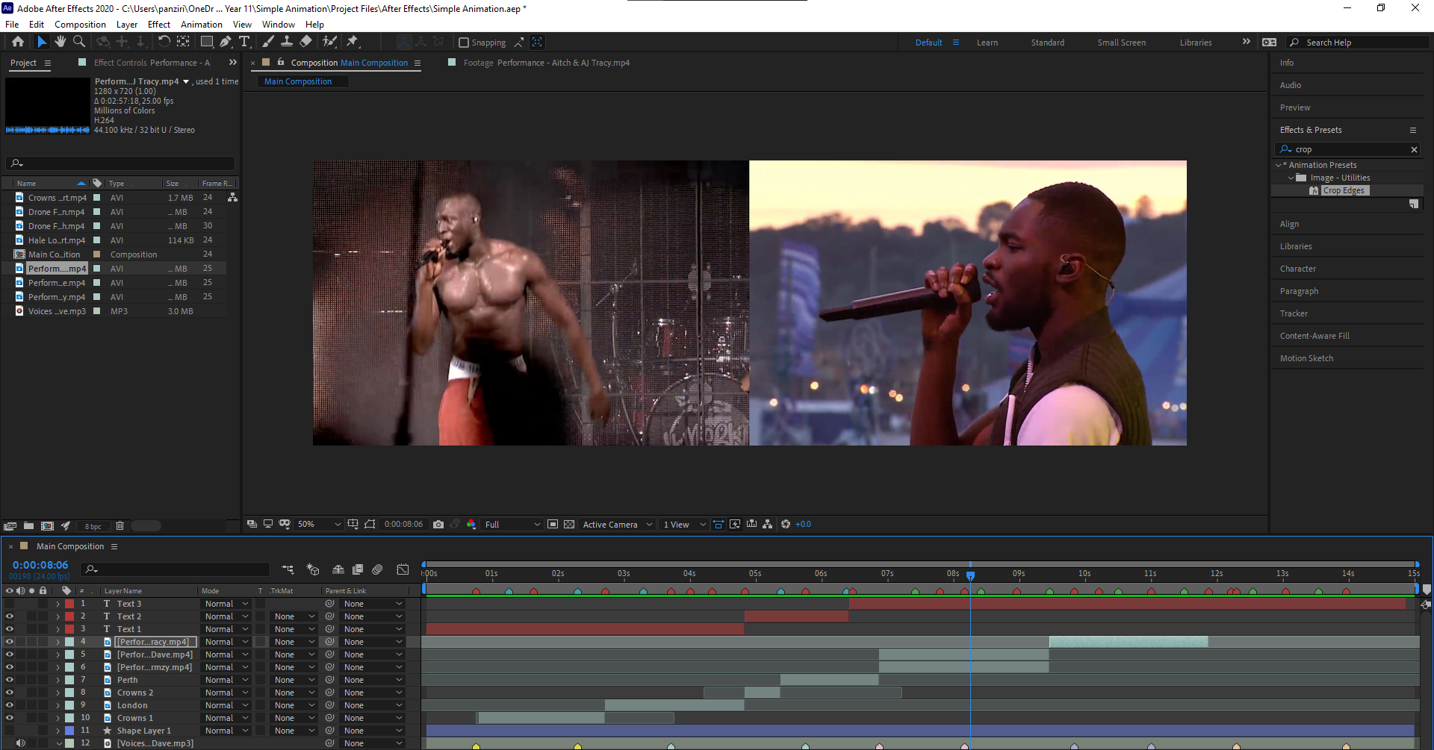 | Now that most of your clips are lined up with audio finish making the text for the artists.
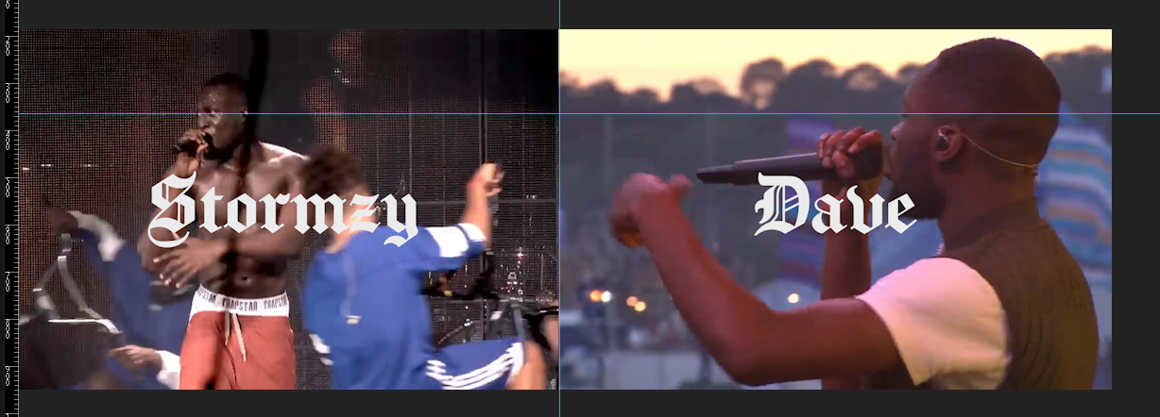 | When you position the video and the text for the stomzy and dave scene, line up their eyes for the first frame.
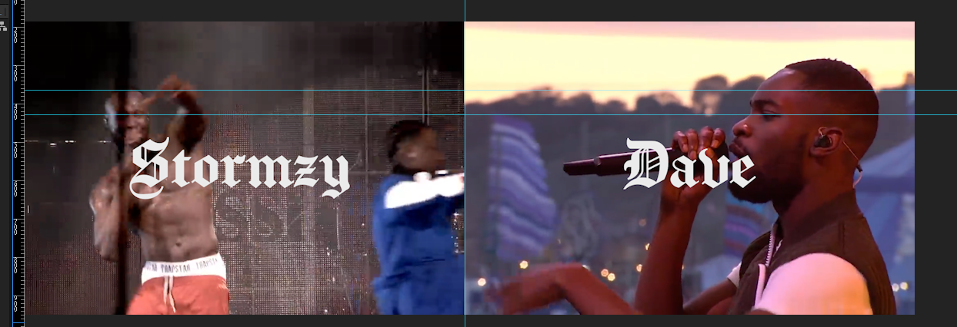 | Then also use positioning keyframes to line up the eyes on the final frame.
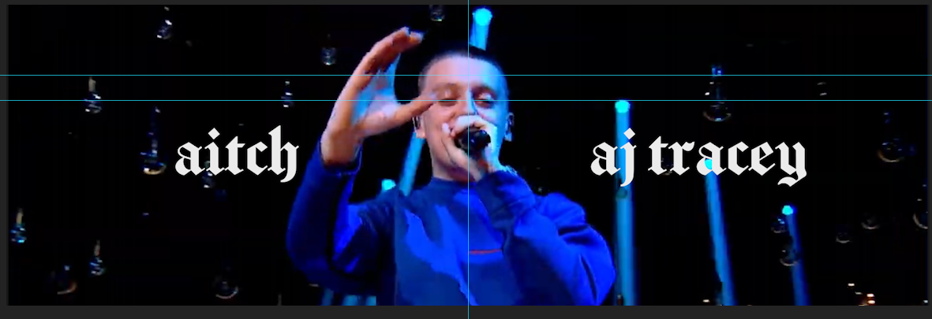 | Then on the next frame use positioning keyframes to make the first frame line up with the last of the last scene then move back to the centre point of attention.
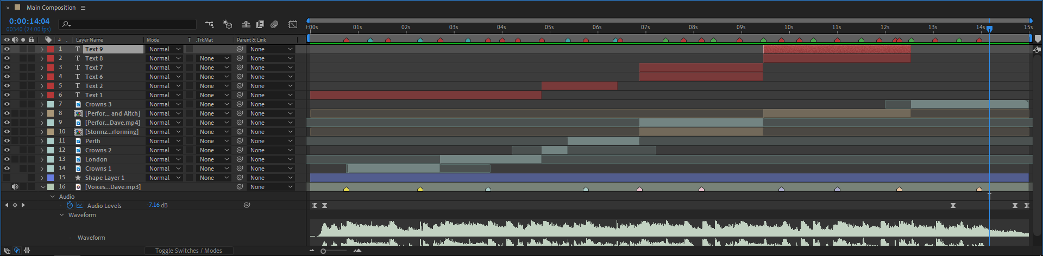 | Once you’ve got all of your clips sorted out, well get started on the hale outro.
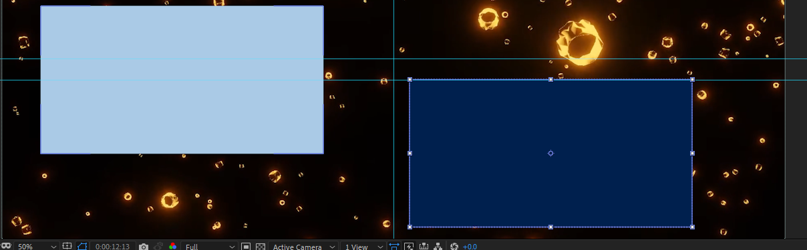 | Create two squares for the outro.
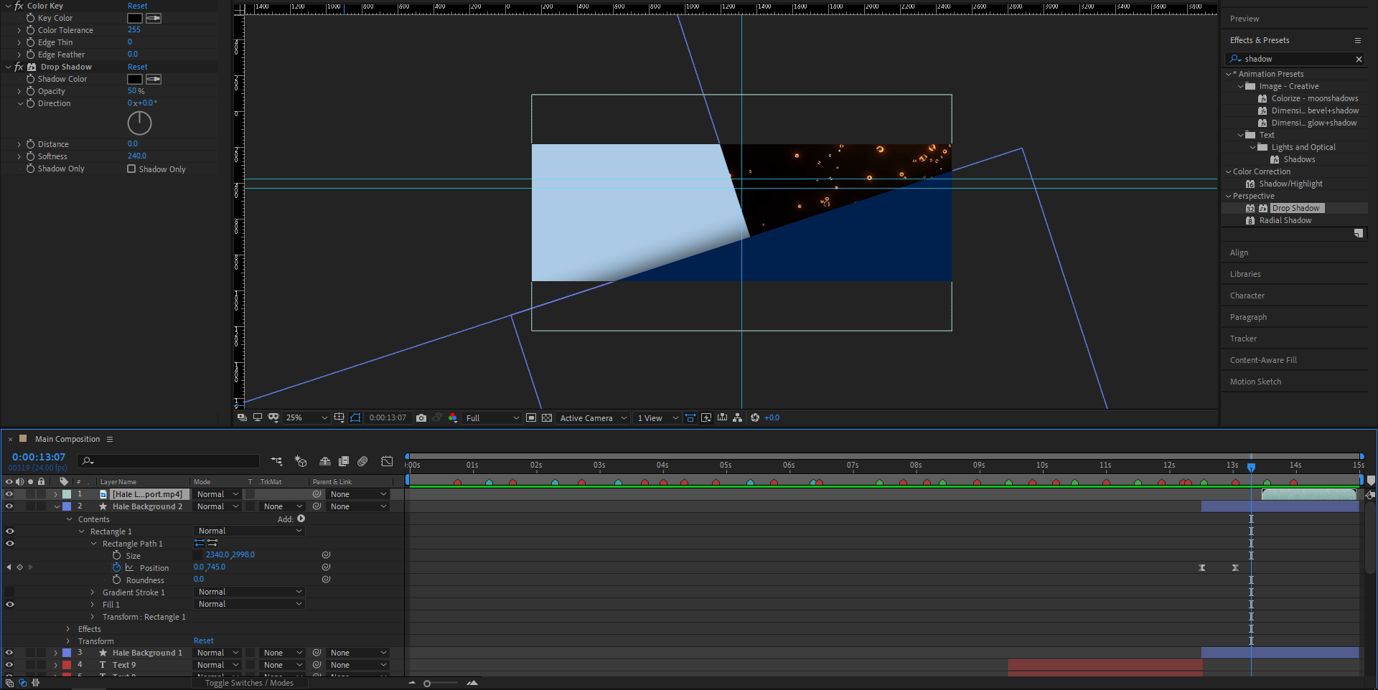 | Then Key Frame the squares to move in.
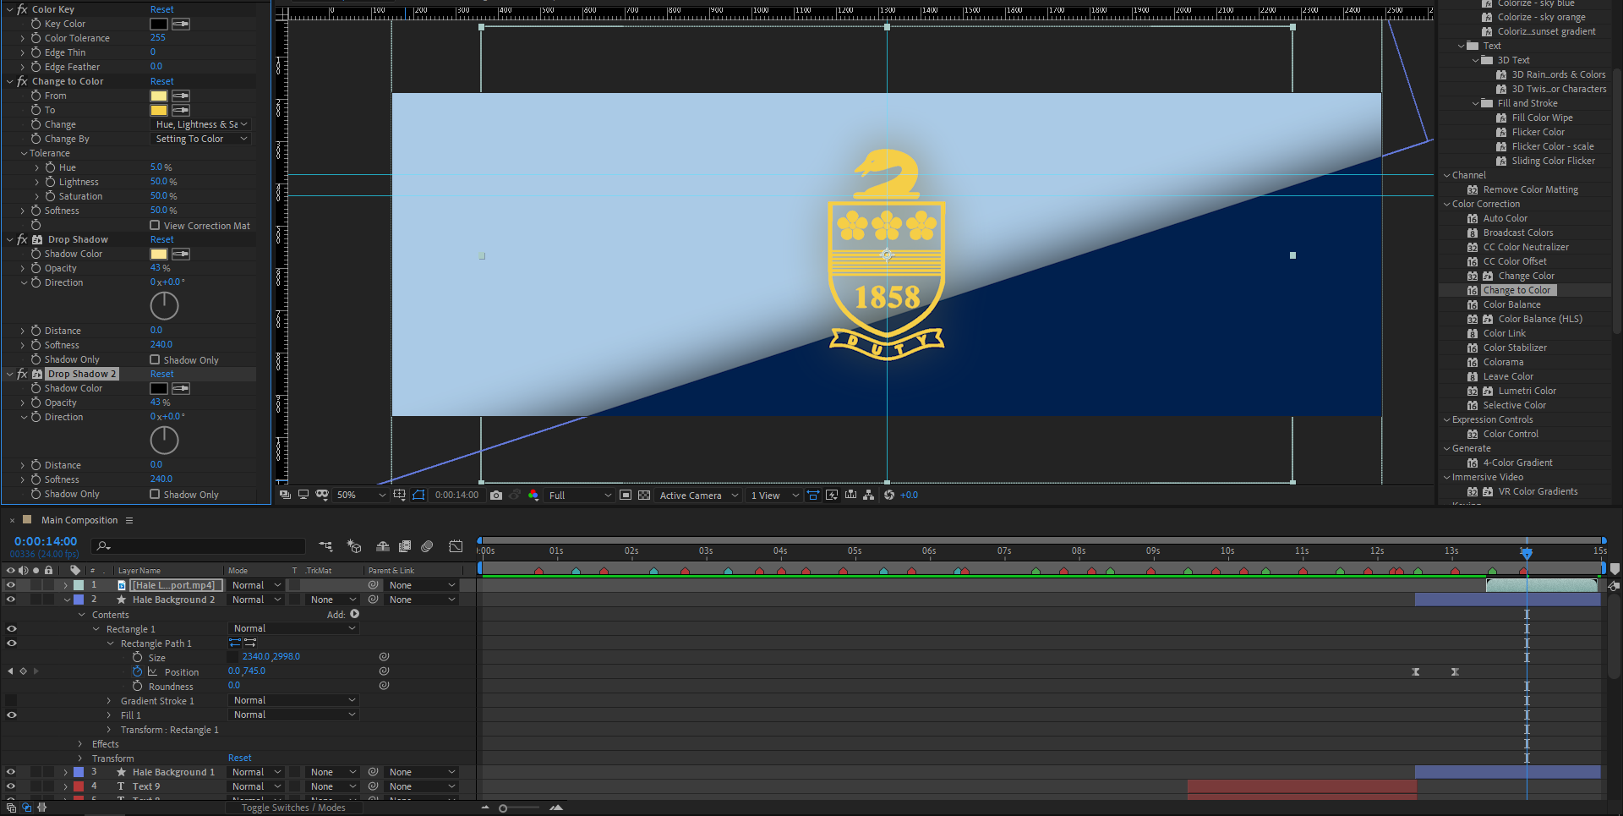 | Then add in the Hale Logo making sure it’s the right colour, colour keying it, giving it some glow with a drop shadow and making it stand out with some drop shadow.
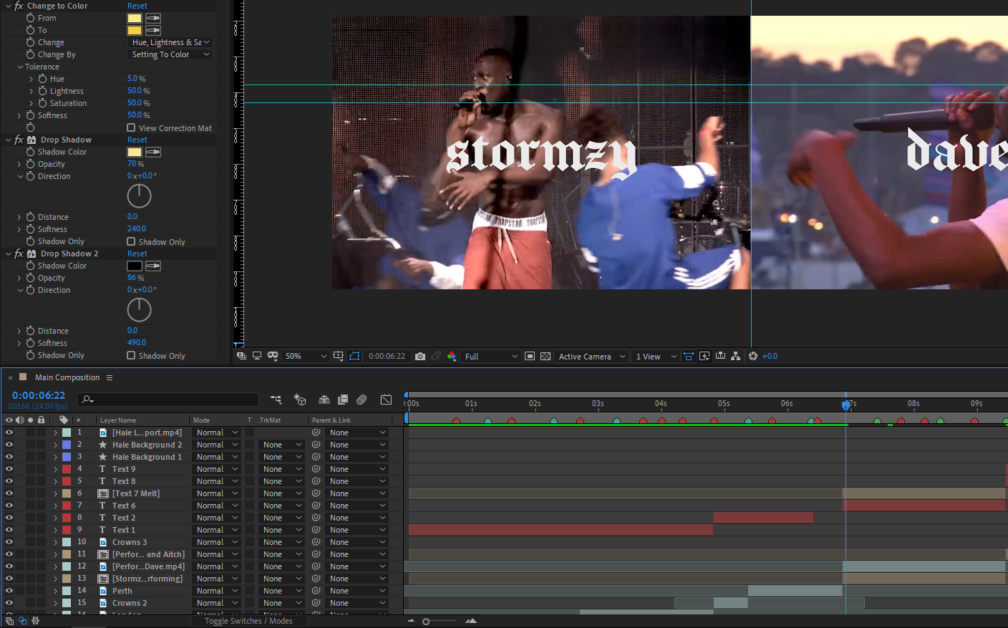 | For anything you want to melt you must create a composition layer for it.
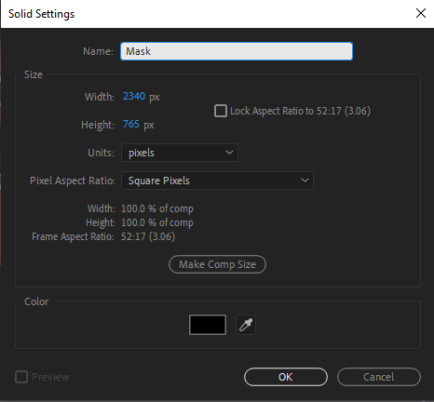 | Create a new solid.
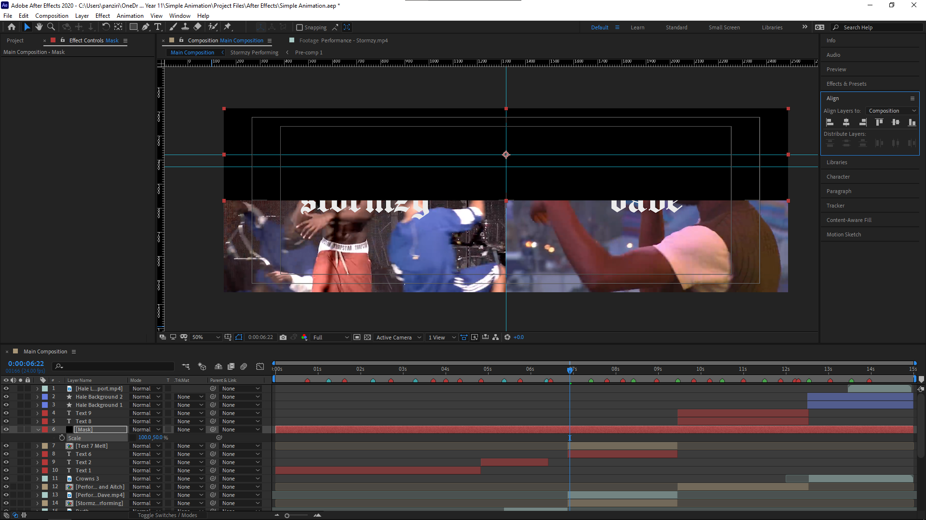 | Set it so 50% Y scale and align it with the top.
 | Change the tack map of the text layer to alpha.
 | Then duplicate it and change it do alpha inverted.
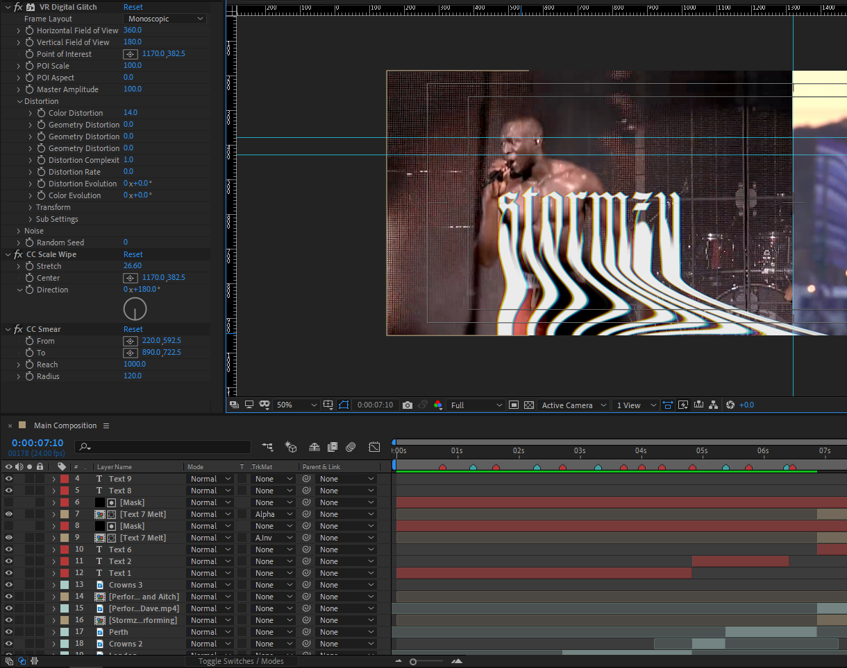 | Add a vr glitch to the top part of the text, and a vr glitch, cc scale wipe and cc smear to the bottom allowing you to melt the text turn this into a pre comp, do this to all the text you want to melt.
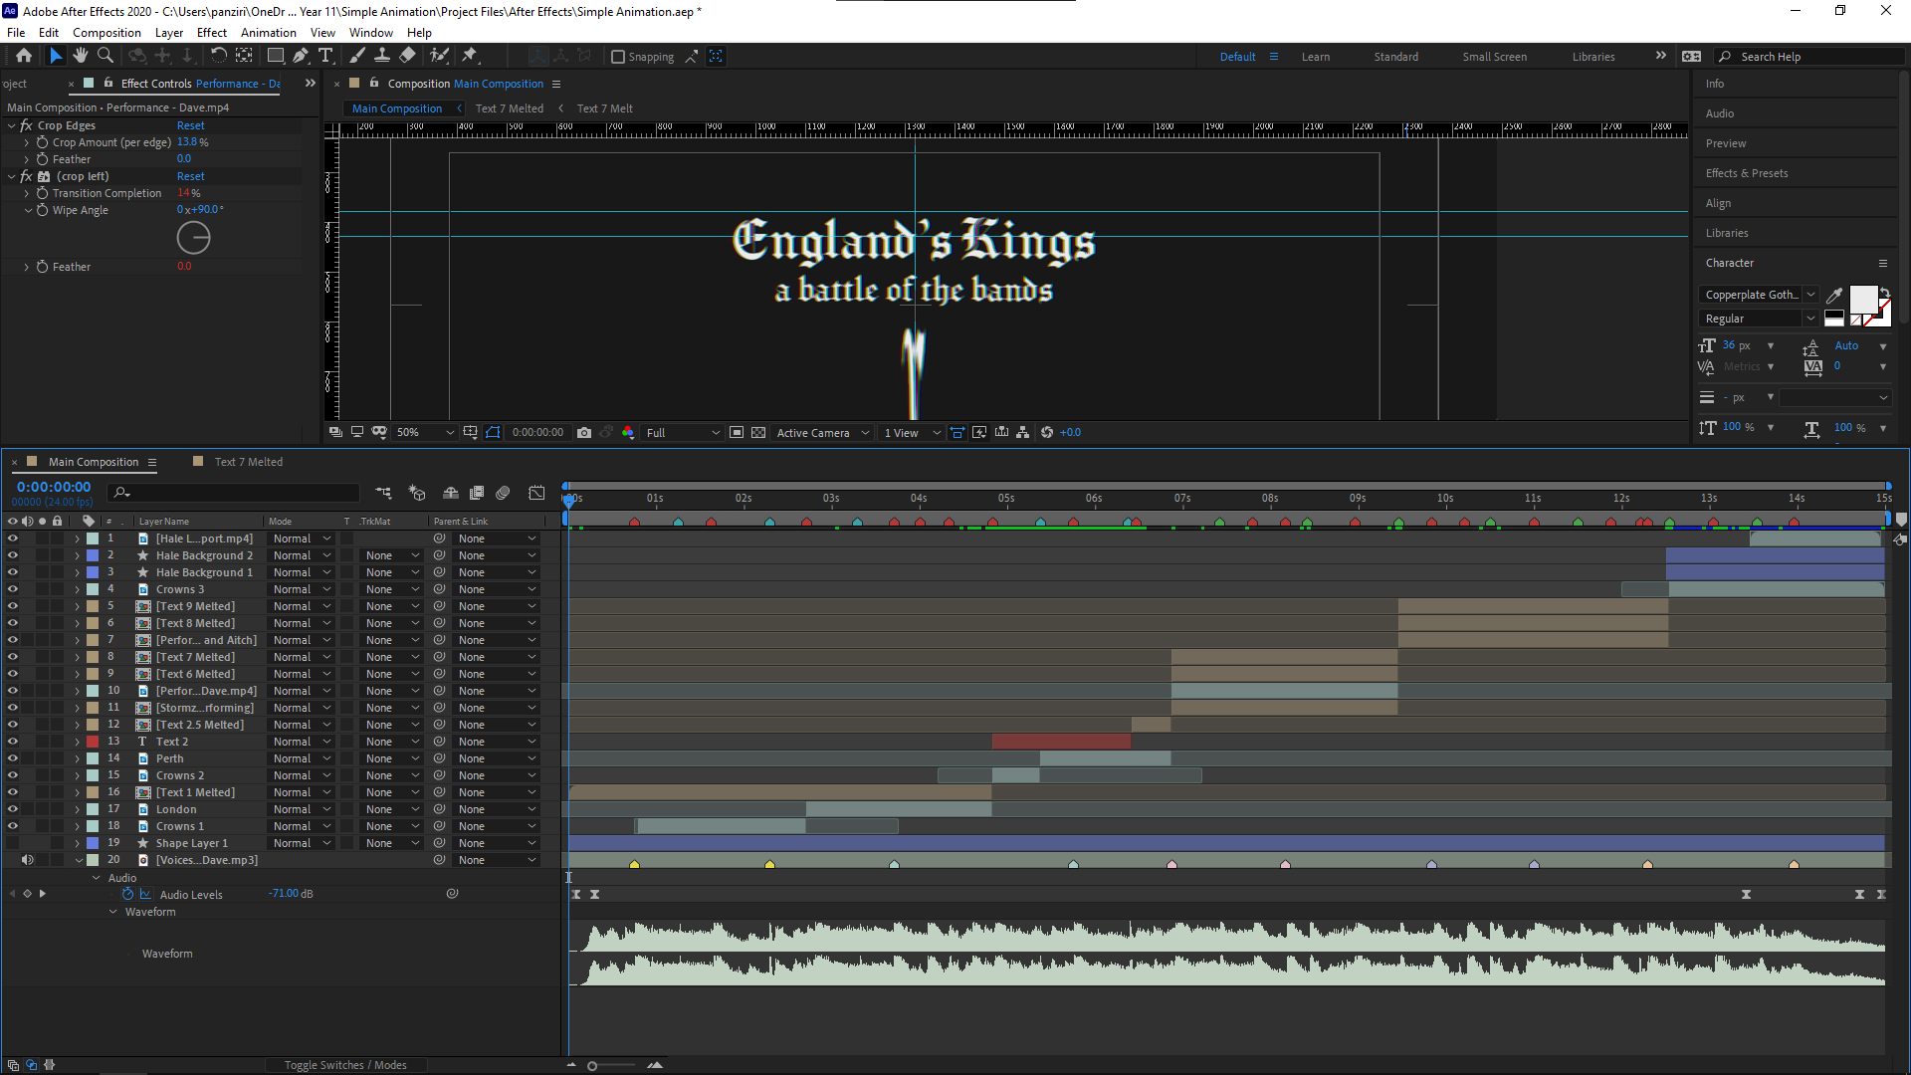 | Then once we’ve made them all melt we need to go into their comp layers and animate the animation to the drops, for the performers make it as close as possible to a 50/50 split and the rest on drops as intros/outros.
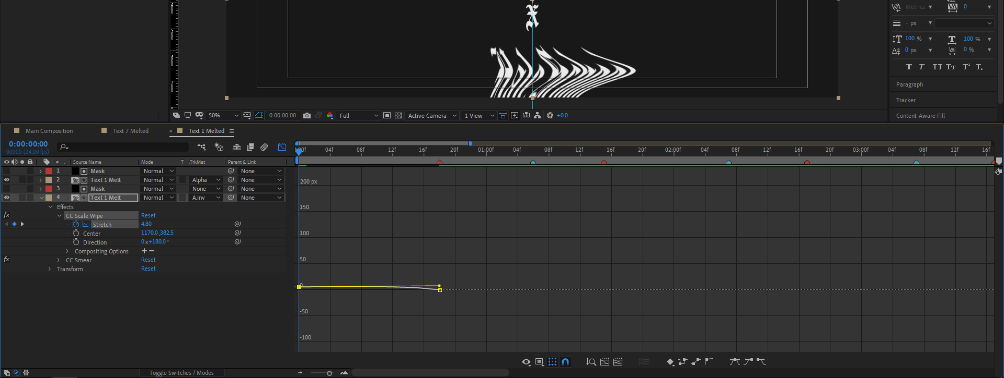 | Adjust the animation curves to add more impact.
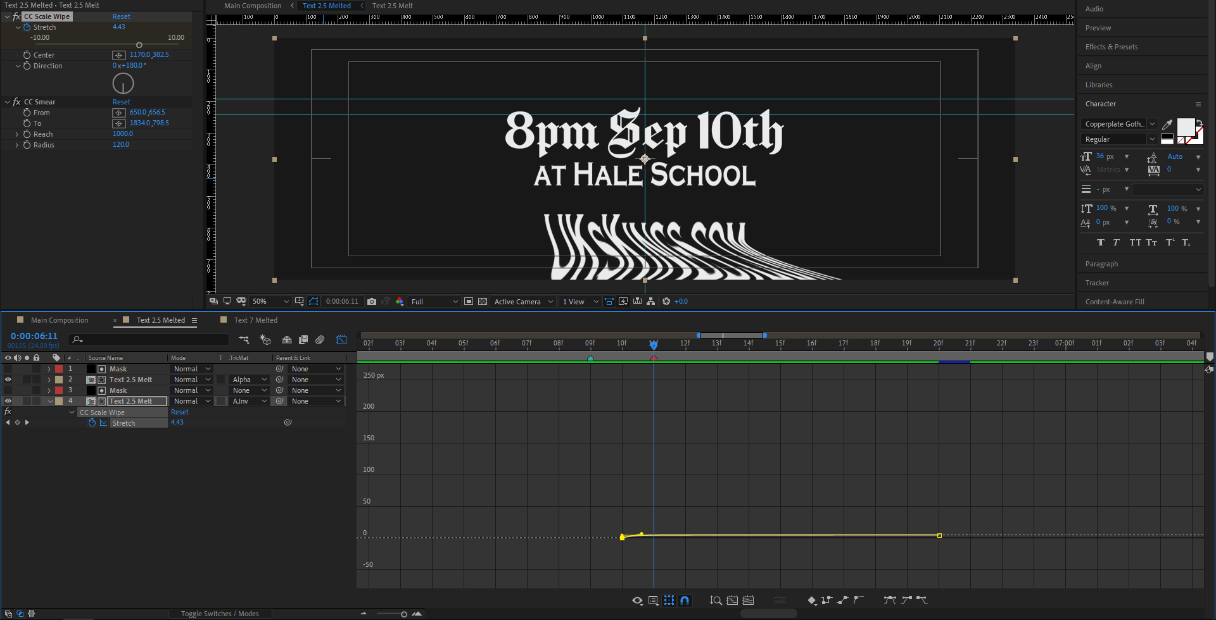 | Continue doing this for all the text.
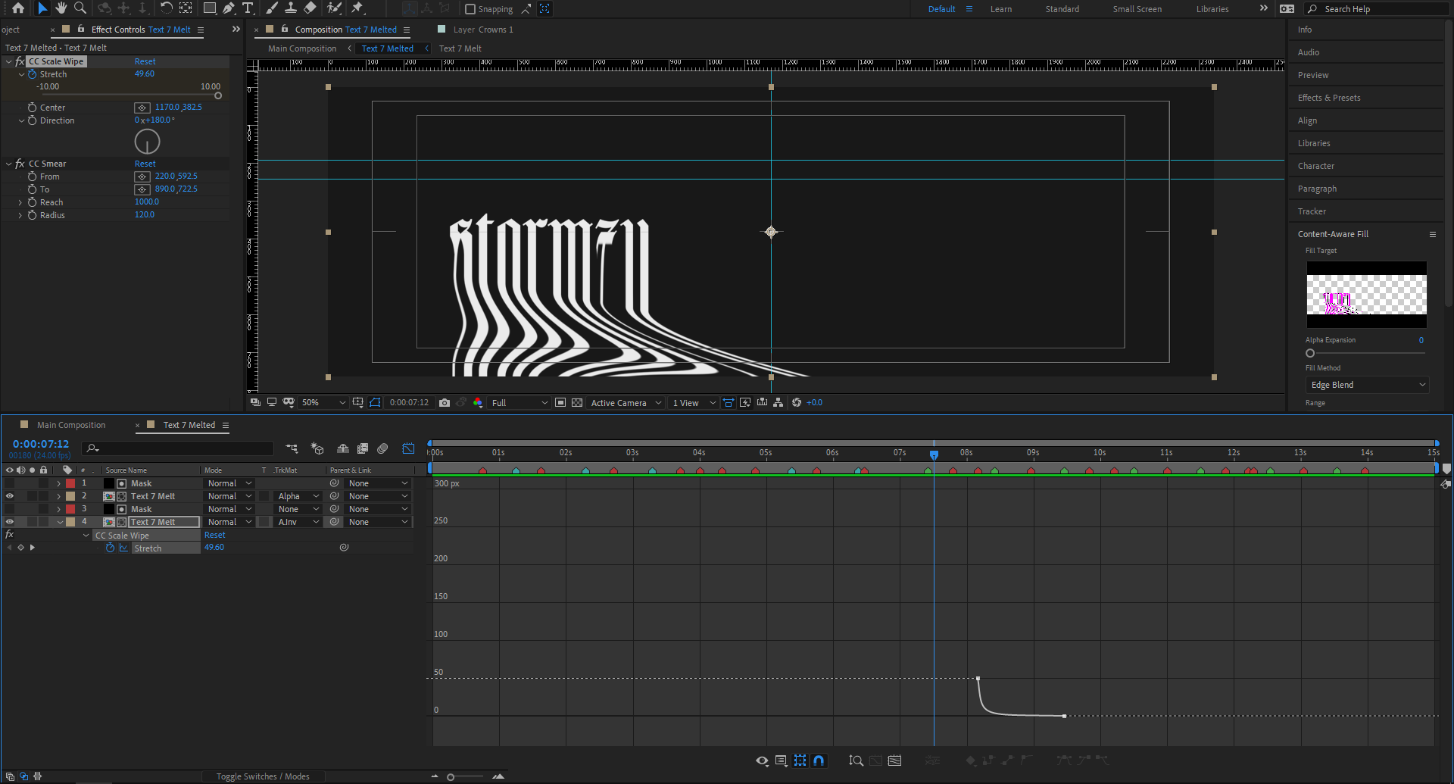 | …
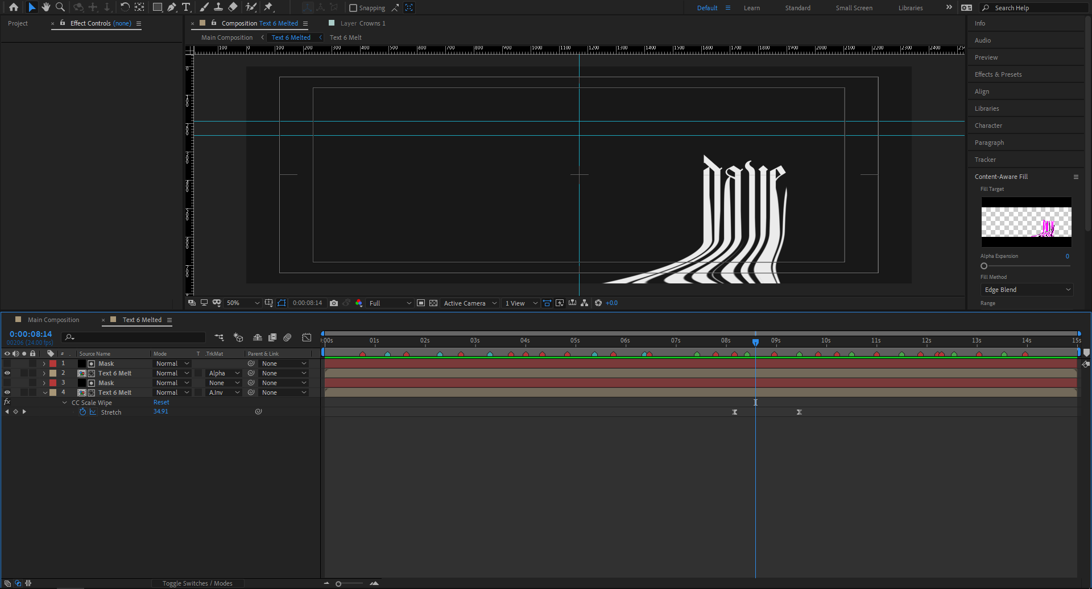 | …
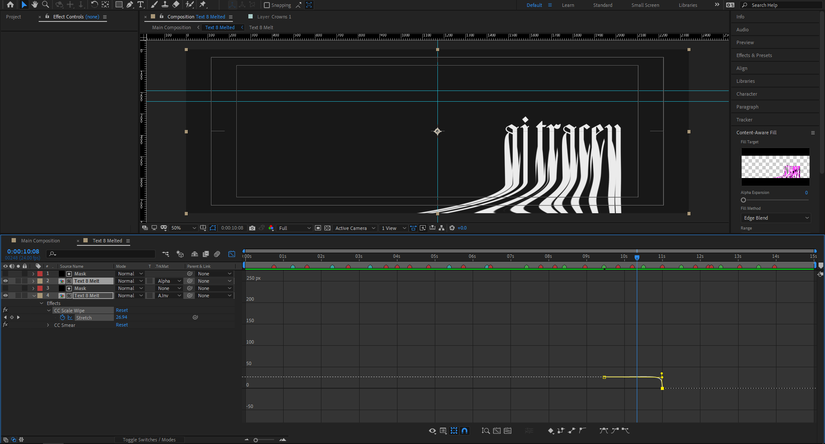 | …
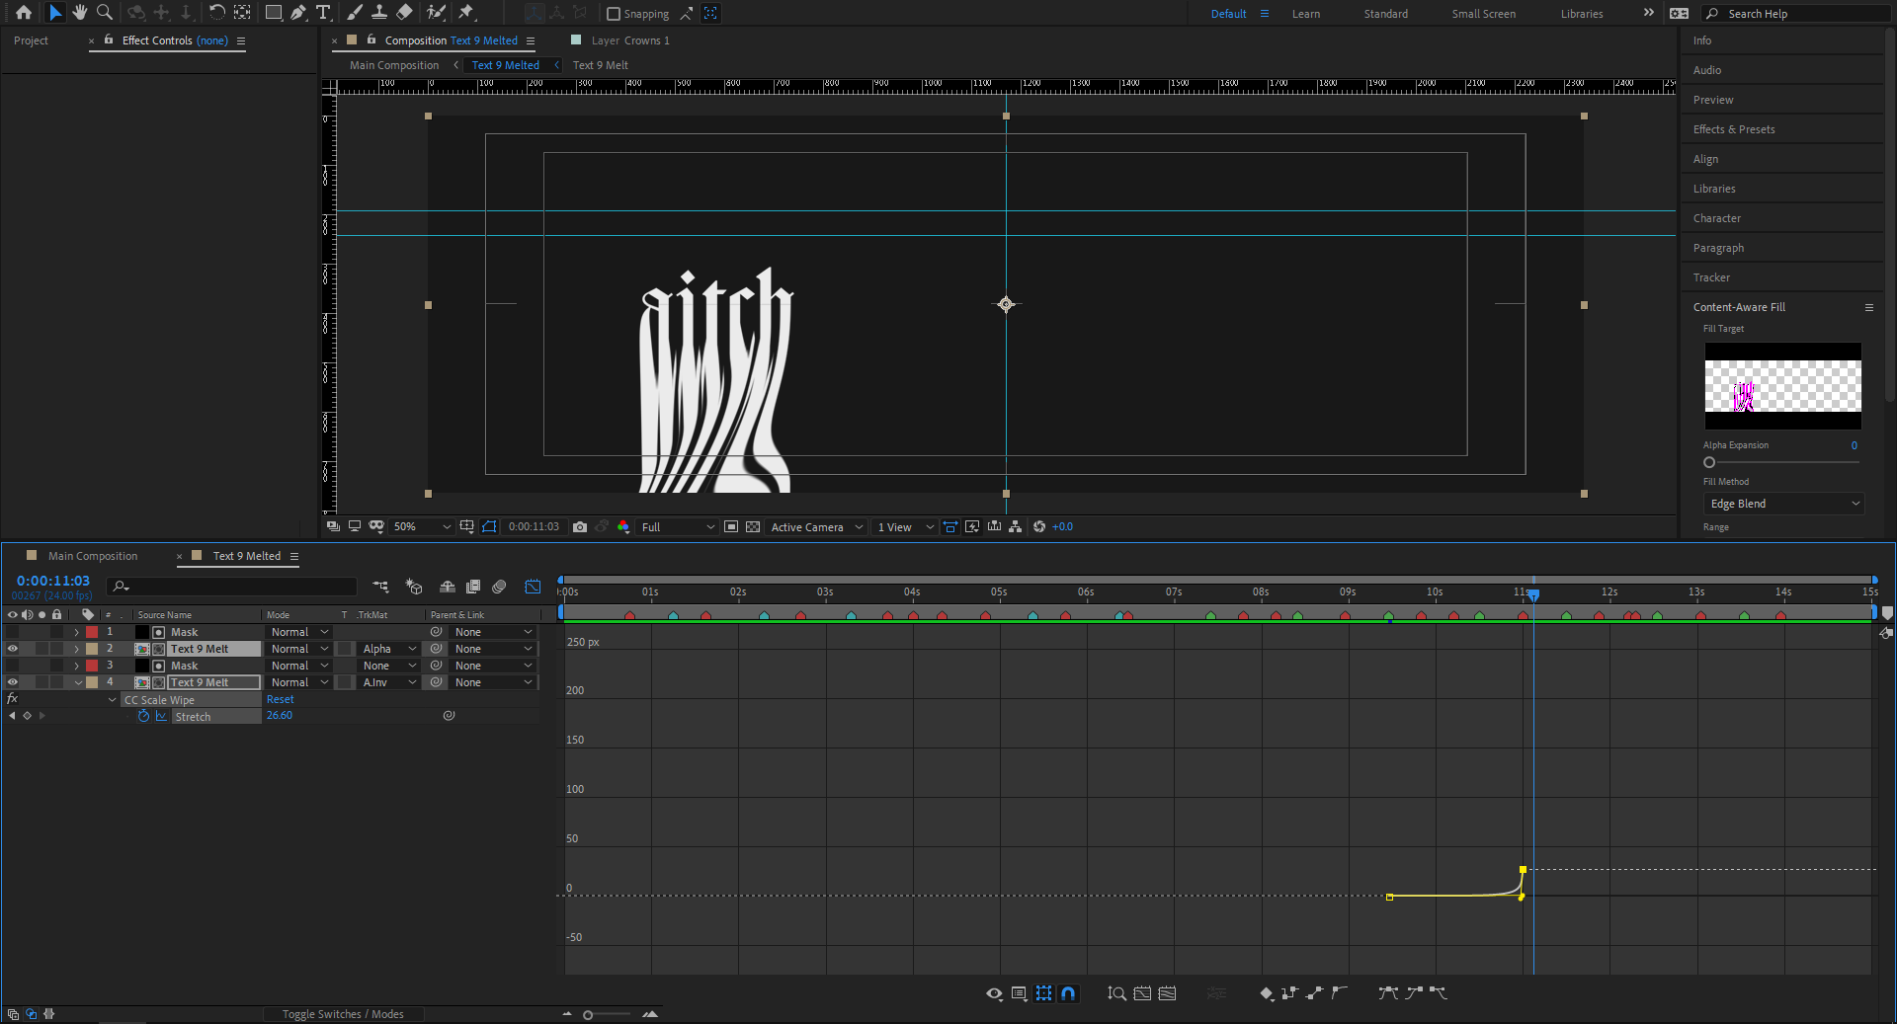 | …
 | Add any tts voice overs.
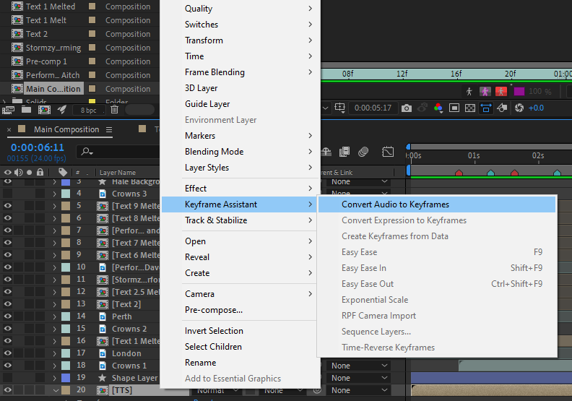 | Right click on the audio channel and use keyframe assistant and convert audio to keyframes.
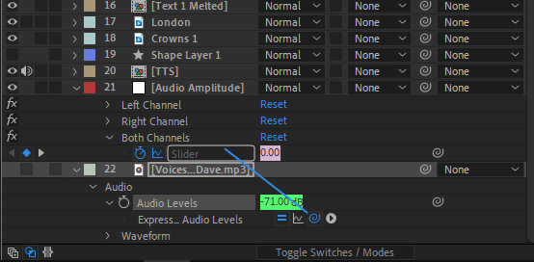 | Then use the whip tool that pops up when alt + left clicking on the keyframe icon of the music layer to link it to a composition of the music volume.
 | Then use this expression.
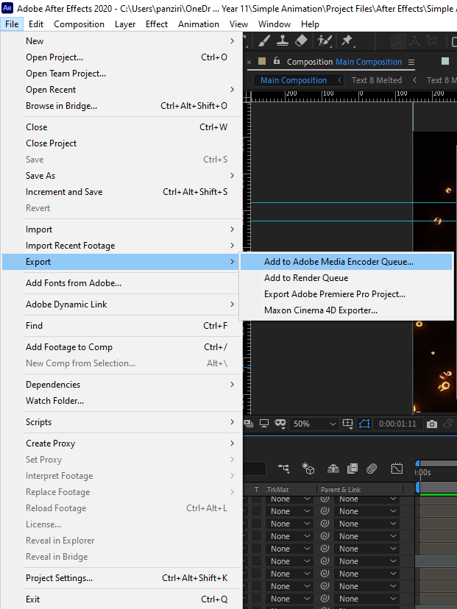 | Then export it as a MP4 for through media encoder.

